Fundraising
The Howard Classroom Project
The Howard Primary School are fundraising for a new classroom. For a number of years, the ambition of the Board of Directors, members of staff, and the parental body, has been to have an additional classroom in order to raise the total number of classrooms to 4.
At present, there is no provision in the village or surrounding area for nursery age children. Children have to travel to access provision. This provision is often oversubscribed due to a growing population, in terms of birth rate and housing development. The school would like to establish an Early Years Foundation Stage Class, which would enable us to provide nursery education in a combined nursery and reception class.
The additional room would be a purpose built Foundation Stage classroom, having the correct layout and toileting provision required for this age of children.
The school and community have been amazing so far in raising funds for the classroom. The goal for 2018/19 is to raise £35,000, and so far we have raised £10,000!

TSSMAT Fundraising Project 2018/19 - Oliver Elliott
Fundraising for Oliver Elliott
We would like to share with you our fundraising project for 2018/19.
We have decided that all three schools within the TSSMAT will try and raise money for a good cause that is very close to our hearts.
Oliver is the son of Mrs Elliot who teaches our children French and as Oliver is part of our extended school family, we felt compelled to help raise money so that both he, and his family’s quality of life can be improved.
We are always overwhelmed by your generosity to help those in need. I know that all three schools will do their very best to raise our target amount of £15k to purchase a communication and language system called “Eye gaze “, so that Oliver will be able to communicate with his mum, dad and brother for the first time – something that we perhaps take for granted.
We appreciate the target amount is considerable but we know that this could be life-changing for both Oliver and his family.
Mrs Elliot has provided us with a little more background about her son which can be seen below. I hope will inspire all of us to get involved with the various fundraising events we’ve got planned.

Oliver is now ten years old. It became very obvious in his first few days that Oliver was unlike any other child. After not achieving his “normal” baby milestones he was given an MRI scan on his brain a year after he was born. The results of the MRI scan showed that his brain was not damaged but it was more or less floating in two halves and that he was missing the major nerve called the corpus callosum. This alone, was not the reason for his delayed development. However, it was a signpost that something was not right. Years of further tests followed and Oliver was put into a group of undiagnosed children that formed a study called “DDD” (Deciphering development disorders) – which was led in Germany. Up to now we still don’t have a full diagnosis for Oliver but have learned to put that to one side and have instead concentrated our attention more into managing his needs and disabilities, which has, in turn made us appreciate Oliver and the person he is.
Oliver is unable to sit alone without support and can only weight bear for very limited periods of time, with the help of his standing frame or an adult holding him. He needs regular on going physio which we do at home and with the help of a private physiotherapist. Oliver’s school also give him daily exercises to develop good movement and to ensure his muscles do not get over-tight.
Oliver has fantastic eye contact and we can judge his level of happiness through his eyes and his laughter. However, he does not communicate verbally at all and so it can be extremely frustrating to fully understand his needs.
Please use the following link to read about a day in Oliver's life:
Oliver Elliott - My Kind of Day
Oliver's "wish list"
A 3 wheeler assisted trike to allow him regular exercise and develop strength. - We have managed to raise enough money to buy olivers trike ready for the Summer! Please use the following like to see Oliver recieving and using his new trike./admin/ckfinder/userfiles/files/Oliver's%20Trike%20June%202018.pdf
A communication and language system called “Eyegaze”would allow Oliver the opportunity to communicate his needs, preferences, likes and dislikes.
A special needs multi terrain buggy will give Oliver and his family more flexibility for travel, off road walks, accessing the beach and also bike rides

If you would like to donate towards Olivers fund please use the link below.
https://www.justgiving.com/crowdfunding/oliver-elliott?utm_id=108&utm_term=BrbEJQDvR
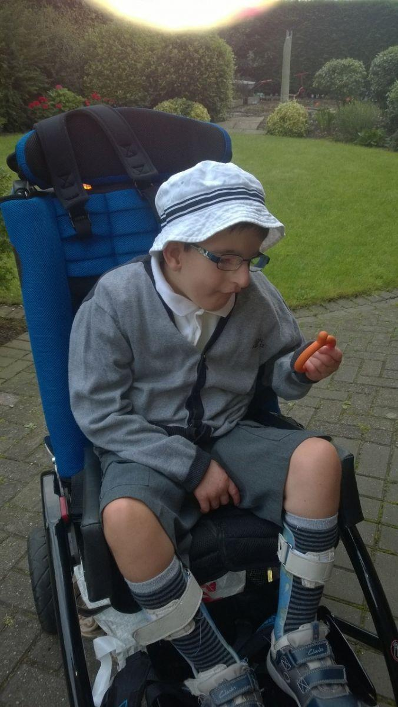
Richard Crosse Primary School started off with a fundraising swimathon. Our children, teachers and parents challenged themselves to "Swimming The English Channel" at our local Lichfield swimming pool. The 22 mile swimathon took place on Saturday 28th April 2018 which was supported by Michael Read, M.B.E, of Channel Swimming Association. The association donated a CSA official flag for the Richard Crosse School, CSA swimming bags, CSA swimming caps, CSA books, CSA car stickers and CSA badges. Michael also signed a CSA book and Rebecca Adlington, OBE, of Becky Adlington Swimstars has donated a course of swimming lessons all of were auctioned off at our Sports Day along with other items of memoribilia.
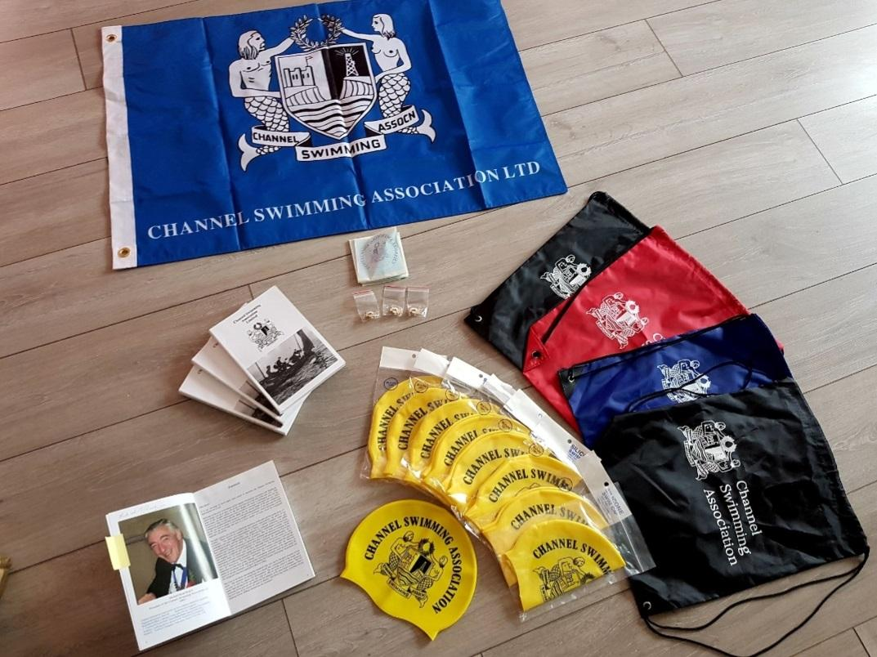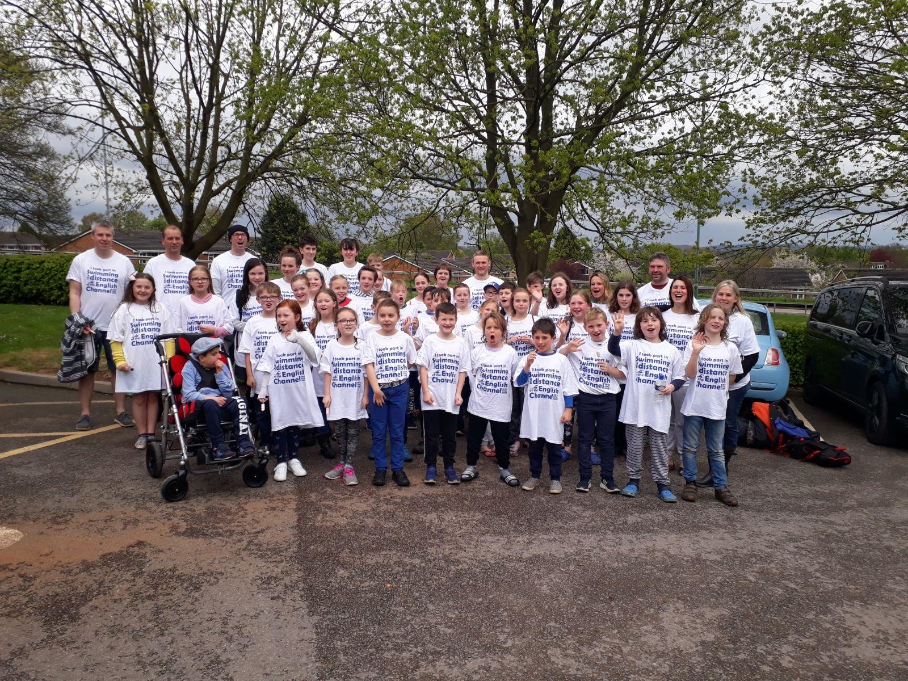
Pupils from Year 3, 4 & 6 at Richard Crosse independently organised jewellery and cake sales at local events, donating all money made to Oliver's Fund.
A Year 3 pupil from Richard Crosse organised a whole school "Richard Crosse has Talent" competition, complete with auditions and finals. The children had a great day showing off their talents and we managed to raise an amazing £130.10!
The children and staff took part in World Book Day in March 2019 - we managed to raise £81.00 which will go to Oliver's Fund. Pictures of this can be found in our gallery!
In April 2019, we will be doing another sponsored swim. We would like all pupils from KS2, ex-pupils, parents and teachers to take part. For more information, please speak to the school office.
We will keep you posted with further fundraising events!

