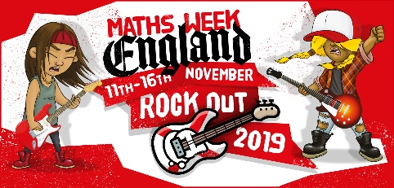
November 2019
Dear parent/carer,
As part of our commitment to make maths exciting and high profile in our school, we are taking part in competition next week that is part of Maths Week England. It’s called Rock Out 2019 and it’s all done online via play.ttrockstars.com.
For every correct answer to a multiplication or division question, your child will earn their class a point. The Times Tables Rock Stars platform will calculate the class average (the number of correct answers per pupil in the class who play during the competition hours). Winning classes in the school and in the country as a whole will be the ones with the highest average.
All game modes (Gig, Garage, Studio, etc.) will count but only from games played between 7.30am and 7.30pm on Monday 11th, Tuesday 12th, Wednesday 13th, Thursday 14th, Friday 15th and Saturday 16th.
In the spirit of the competition, please don’t play on their behalf but by all means encourage and support them to the extent that it doesn’t cause high stress levels or impact on family plans. We suggest a limit of half an hour a day outside school hours – some will play more, some will play less.
Thanks for your support,
Team Howard

