# Image result for children stick men schoolImage result for the howard primary school elford/var/folders/21/3wzfs1tj7f32lts6pl9vm6p40000gn/T/com.microsoft.Word/Content.MSO/335C0DF1.tmp/var/folders/21/3wzfs1tj7f32lts6pl9vm6p40000gn/T/com.microsoft.Word/Content.MSO/335C0DF1.tmp/var/folders/21/3wzfs1tj7f32lts6pl9vm6p40000gn/T/com.microsoft.Word/Content.MSO/335C0DF1.tmp

# Related image

# **The Howard Primary School**

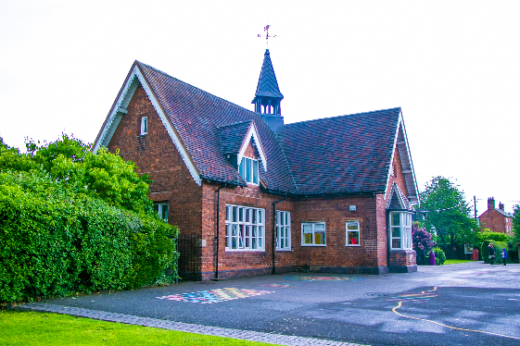R

**If you have a child of Reception age (4 years old before September) please come and visit our school**

**Give us a call to book a personalised tour**

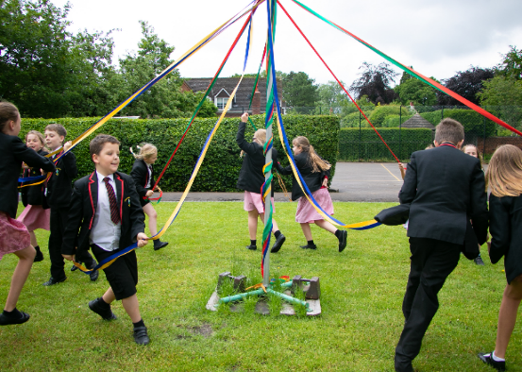

**Meet our excellent staff**

**See our happy, engaged children**

**View our extensive grounds**

**September places available for 4 year olds**

**For more information, please call 01287383292 or email howardoffice@tssmat.staffs.sch.uk**

**The Square, Elford, Tamworth, D79 9DB**